DR. AMBEDKAR COLLEGE, DEEKSHABHOOMI, NAGPUR
DEPARTMENT OF LAW
Academic Session - 2019-2020
NAME OF THE PROGRAMME: 1. AIR CAMPUS PLACEMENT (PSYCHOMETRIC TEST)
2. GUEST LECTURE ON LEGAL CAREER GUIDANCE
NAME OF THE GUEST/ RESOURCE PERSON: ADV. SHIRISH GADGE
NAME OF THE PROGRAMME CO – ORDINATORS: 1. DR. SANDHYA KALAMDHAD
2. MRS.VAISHALI SUKHDEVE
DAY: 29TH JULY, 2019 (MONDAY)
TIME: 10.30 AM – 12.30 PM
VENUE: SEMINAR HALL, DR. AMBEDKAR COLLEGE, DEEKSHABHOOMI, DEPARTMENT OF LAW, NAGPUR.

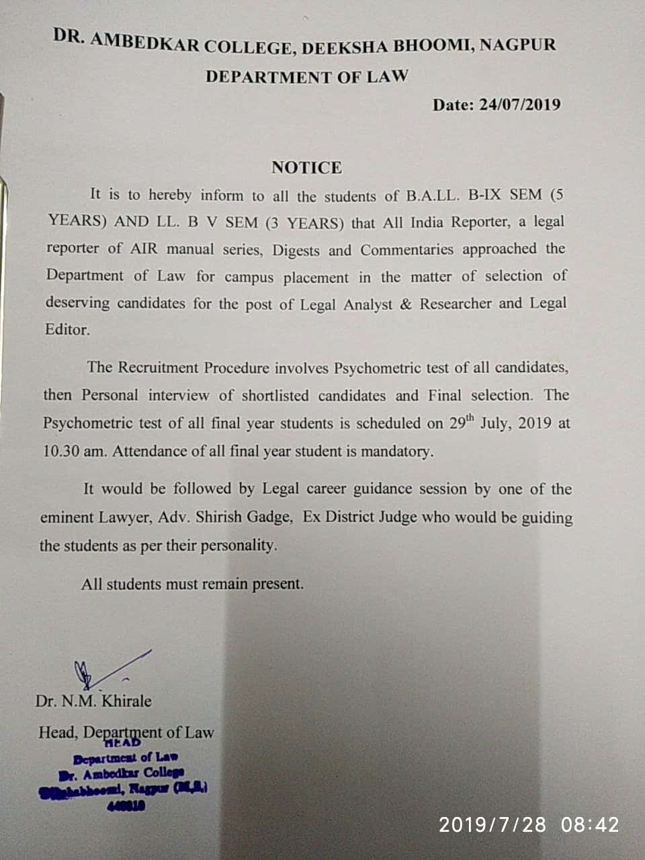
REPORT
All India Reporter, a Legal Reporting in AIR Manual Series, Digest and Commentaries, arranged a Campus Selection for Final year students of Five years degree Programme and Three years Degree Programme, followed by a Guest Lecture on “ Legal Career Guidance” by Adv. Shirish Gadge, Ex District Judge.
22 male students and 33 female students participated in the programme. The programme began with the Psychometric test where students were evaluated on the basis of personal details and personalities profile. Immediately after this, results were declared and according to the results, the students were grouped into four groups. After this, as per their performance, they were guided by Adv. Shirish Gadge as to which career they should opt after their Law graduation.
Students got benefited from this lecture. Mr. Jeet Biswas, a student of Final year conducted the proceeding and Dr. N.M. Khirale, Head of the Department of Law proposed a vote of thanks. The programme was conducted under the able guidance of Dr. Sandhya Kalamdhad and Mrs. Vaishali Sukhdeve. All the teachers of the Department of Law were present for the programme.
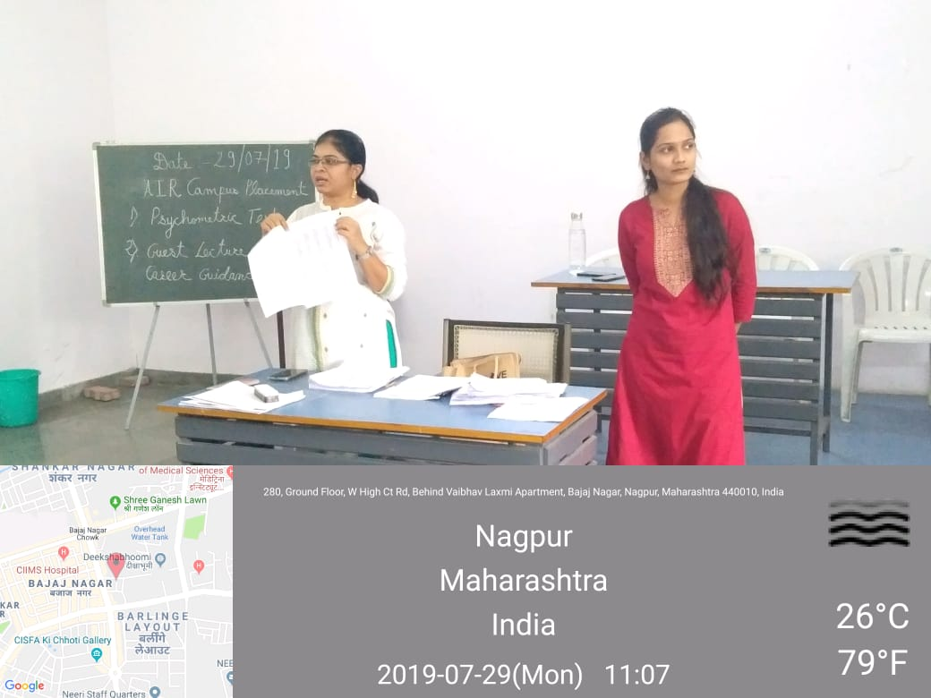
Mrs. Renu Joshi explaining the students about how to solve the Psychometric test.

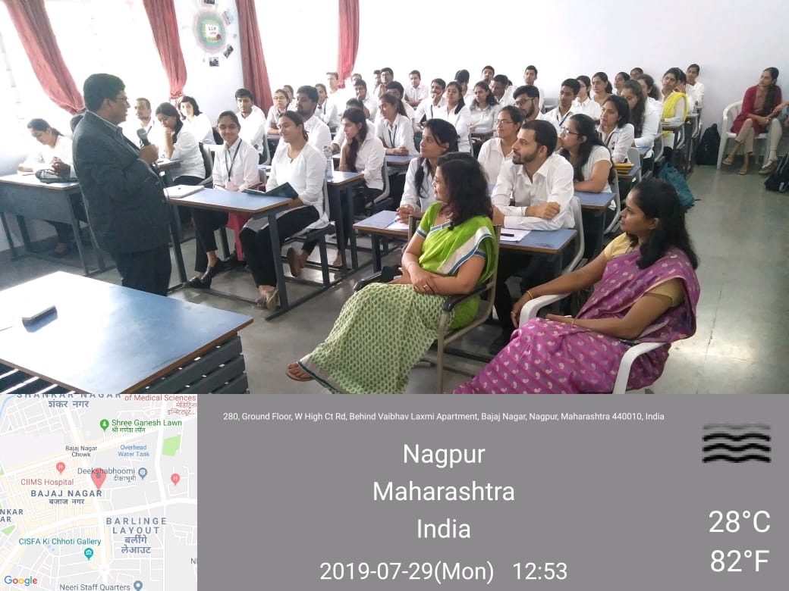
Adv. Shirish Gadge explaining the students of different personality traits.
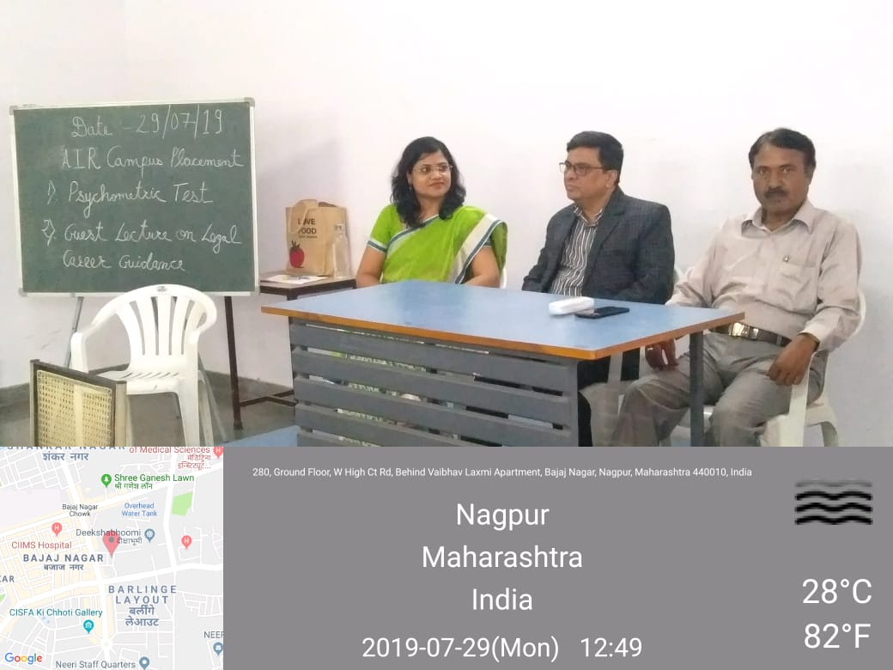
Adv. Shirish Gadge, Dr. N.M.Khirale, Head of Department and Dr. Sandhya Kalamdhad sharing dais.

